OFFICE HOURS: 9:00am – 4:00 pm; Monday – Thursday
9:00am – 3:00 pm; Friday

Associate Ministers  Rev. Ken Blacknell | Ministers of Evangelism  Min. Karen Blacknell
Elder Chris Evans  Rev. Garfield Garner  Rev. Eugene Graves | Evang. Geneva Burse  Evang. Valerie A. Montaque  Evang. Ruthell Morris
Min. Shurron Green | Evang. Kimberly Rogers
Rev. Stanley Jackson | Min. Monique Stroman
Rev. Artis Johnson | Min. Barbara Williams
Min. Larry Jones
Rev. Timothy Twyman
Rev. Stanley Williams
Rev. Alton

OPPORTUNITIES TO SERVE
WEEKLY
Bible Study (Adult) | Wednesday ^{(In person & Virtual)} | Fbcduluth.org
Deacon’s Meeting | Tuesday ^{(1st /3rd)} | 7:00 pm
Marriage Ministry | Sunday | 9:45 am
New Members Class | Sunday | 9:45 am
Sunday School | Sunday | 9:45 am
Sunday School Teachers | Wednesday ^{(Inperson & Zoom)} | 6:30 pm
Sunday Worship | Sunday | 11:00 am
Teen Church | Sunday | 11:00 am
MONTHLY
Gospel Choir Preparation | Tuesday before 1st Sunday | 7:00 pm
Health Ministry | Saturday ^{(2nd)} | 11:00 am
Shepherds Care | Saturday ^{(1st)} | 9:30 am
Education Ministry | Monday ^{(2nd)} | 7:00 pm
Communication Ministry | Saturday ^{(3rd)} | 11:00 am
Creative Learning | Saturday ^{(2nd)} | 10:00 am
Gatekeepers Ministry | Saturday^{(4th)} | 10:00 am
Male Chorus Preparation | Saturday ^{(2nd)} | 9:30 am
Men’s Ministry | Saturday ^{(1st)} | 9:00 am
Minister’s Meeting | Saturday ^{(1st)} | 3:00 pm
Mother’s Ministry | Saturday ^{(1st)} | 9:30 am
Outreach Ministry | Saturday ^{(3rd)} | 9:00 am
Praise Team | Tuesday ^{(3rd)}
Senior’s Ministry | Saturday ^{(4th)} | 11:00 am
Usher Ministry | Tuesday ^{(1st)} | 7:00 pm
Women’s Ministry | Saturday ^{(2nd)} | 8:45 am
Youth Choir Preparation | Saturday ^{(4th)} | 10:00 am

Holy Communion 1st Sunday 11:00 am
Baptism 3rd Sunday 11:00 am
Baby Dedications 4th Sunday 11:00 am
Rev. Ronald L. Bowens, Pastor

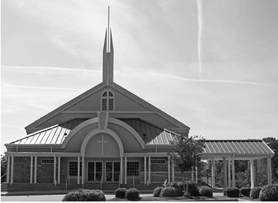

Mission Statement
Exalt the Savior * Equip the Saint * Evangelize the Sinner

A Purpose Driven Church
Friendly through fellowship ▪Developed through discipleship
Enlarged through evangelism▪ Sharing and caring through servanthood ▪ Stronger through God’s Word and true worship

3375 Church Lane, Duluth, GA 30096
(770) 497-8227 office - (770) 497-9775 fax
www.friendshipduluth.org
fbcduluth@att.net

Order of Worship
April 14, 2024 Theme: The Word of God
•+Welcome & Opening Comments
•+Opening Prayer

•+Call to Worship (John 1:1-3 NASB)
1 In the beginning was the Word, and the Word was with God, and the Word was God. 2 He was in the beginning with God. 3 All things came into being through Him, and apart from Him not even one thing came into being that has come into being.

•+Hymn of Praise Hymn #340 “What a Friend We Have in Jesus”

•+Special Announcements

•+Selection

•+Tithes & Offering (II Corinthians 9:6-8) Officers
But this I say, He which soweth sparingly shall reap also sparingly;
and he which soweth bountifully shall reap also bountifully.

Every man according as he purposeth in his heart, so let him give; not grudgingly, or of necessity: for God loveth a cheerful giver.

And God is able to make all grace abound toward you; that ye, always
having all sufficiency in all things, may abound to every good work:

•+Moment in Prayer
•+Selection

•+Preached Word Pastor Bowens
+ Call to Discipleship

Altar Call and Benediction Pastor Bowens
• Please Stand +Worshippers will not be allowed to enter/exit sanctuary

Church Announcements
- Prayer Meeting 6:30pm
- Bible Study 7:00pm

7pm via zoom
Spiritual Warfare: Biblical Truth for Victory!
You are cordially invited each Monday night as we gather together to glorify God through fellowship with one another and to study God’s word. For more information contact - Deacon Michael Bailey at 770-595-4199

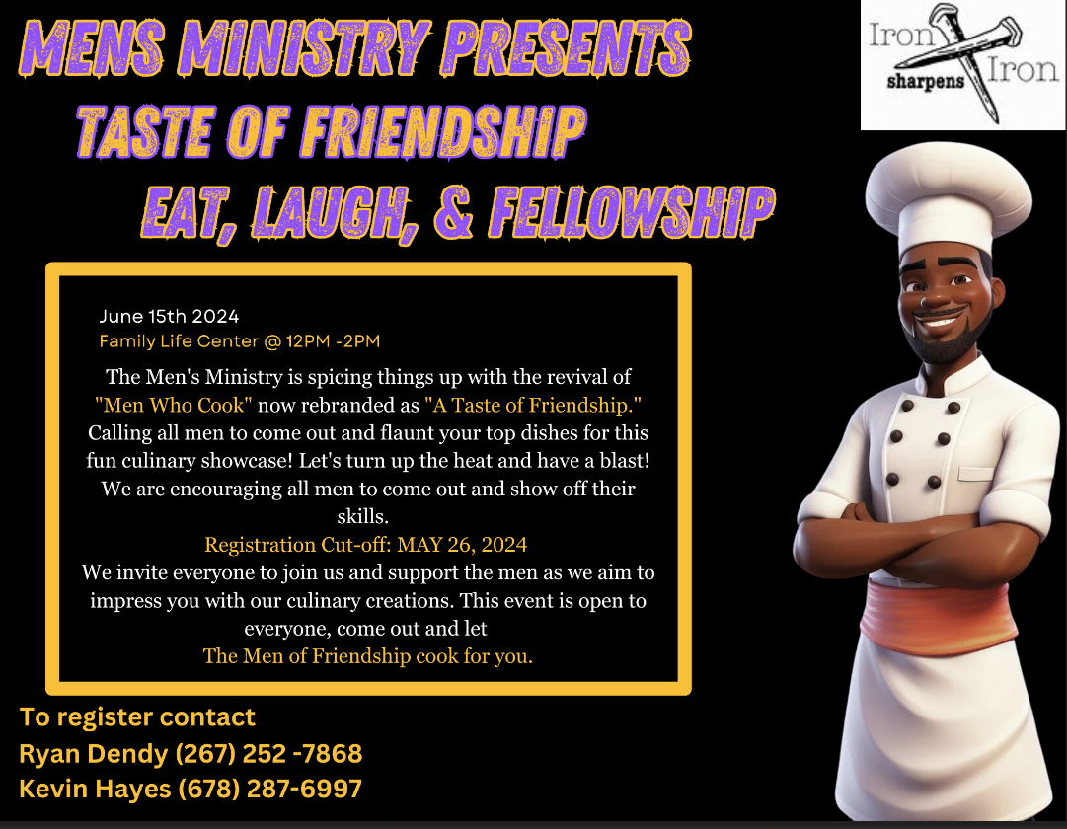

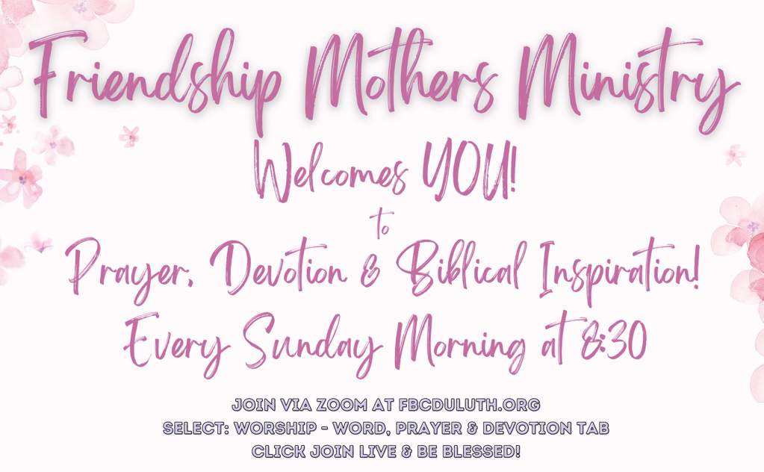
Communication Ministry
The March 2024 issue of the FBC Newsletter is now available on the church website, fbcduluth.org. This issue includes The Resurrection of Jesus Christ, Signs of the Season, A Celebration of Women, Moments in Black History plus highlights of various ministry activities. Contact Paulette Tapp at ptapp1052@gmail.com or phone at 678-779-4661 if you have questions.

Church Announcements
Volunteers Needed for the following ministries:

Greeter’s Ministry is looking for volunteers especially a few good men. If you are interested, please contact Deacon Edward Johnson at 678-910-5069.

Sunday school is in full force and is looking for a few dedicated and called teachers. If this is you, please contact Bro. Dorian Rogers, Sunday school Superintendent (770) 309-6245.

The Music Ministry is looking for new members 18 years or older. If interested in the Gospel Choir, please contact our Minister of Music, Bryan Bowens @ 678-200-9443. If interested in the Male Chorus, please contact Deacon Derick Chambers @ 678-863-4046.

Thank You Thank you for the cards, calls, prayers, thoughts and all other acts of kindness and sympathy during our time of loss. May God bless all of you richly. Regina Woods and family

Church Announcements
The MasterLife Series - MasterLife is a developmental, small-group discipleship process, comprised of four books. Each book will be taught over a period of six weeks by a different instructor. Please register for this class on the church website, fbcduluth.org.

Outreach Ministry -- Mission Statement: “ONE BODY SAVED TO SERVE” “ONE BODY SAVED TO SERVE” is the Mission Statement for the Outreach Ministry at Friendship Baptist Church and SERVE is what we do by sharing God's bounty and blessings with our neighbors and the greater Community. The Friendship Market offers a variety of healthy food options including meat and vegetable protein, produce, fruit and more and it is open and available to all who can USE it. Current hours are: Fridays 3:00 pm - 5:00 pm. Items will be distributed at the Fellowship hall; just drive through and we’ll be there waiting for you! The FBC Outreach Ministry: “One Body Saved to Serve” Seniors Ministry Are you 55 years or older? We would love for you to attend the Seniors’ Ministry Fellowship on Saturday, April 27th at 11:00 am in the Family Life Center. Come for fellowship, to be encouraged through prayer and scripture reading, as we plan senior activities such as trips to local farmers markets, shopping, experiencing different restaurants for 2024. We look forward to seeing you! Psalm 92:12-15 Any questions, contact Rev. Eugene Graves at 770-710-5016 or Brenda Graves at 770-710-5128.

The Education Ministry is hosting a Day of Education & Fun on Saturday, May 18th for student’s 3rd – 5th Grade. More information to come.

Church Announcements
No eating or drinking in the sanctuary at any time. Please silence all cell phones. Nursery (Age 3 mths – 3 yrs or potty trained) opens @ 9:45 am located in the Fellowship Hall.
Youth Church – Ages Pre-K:3 (potty trained) – 6 years and Elementary 7-12 years in the Family Life Center.
Teen Church (Middle/High school) OPEN- Services held in Heritage sanctuary

Prayer List – remember with prayer, calls & visitations.
Mr. William Annan  Sis. Charre Armstrong  Sis. Pat Ashe  Bro. Charles Bailey  Bro. Willie Benton  Min. Karen Blacknell  Sis. Sheila Blackwell  Dea. Willie Blake  Bro. Don Bowens  Sis. Liz Bowens  Bro. Isaac Brown  Barbara Williams Brown  Sis. Alice Burnes | Sis. Wanda Burrell  Bro. Dwayne Bynum  Sis. Chastity Collier  Sis. Sarah Collins  Dea. Kevin Corbett Sis. Ruth Ellis  Sis. Andrea Green  Sis. Ruth Griggs  Sis. Barbara Hall  Bro. Emanuel Hazell  Sis. Dorothy Hines  Willie Irvin  Bro. Patrick Jones  Sis. Mabel Lawrence | Sis. Virginia McLemore  Sis. Thelma Matthews  Sis. Josephine May  Bro. Will May  Miss. Kaitlyn Miles  JC Mitchell  Sis. Alice Murphy  Sis. Teresa Rainey  Sis. Carrie Rawls  Sis. Letitia Robinson  Sis. Linda Rogers  Sis. Carrie Royals  Bro. Rennie Samuels  Sis. Jacquline Scott | Sis. Tonya Sellers  Bro. Rudy Simmons  Mr. Claudius Stafford  Bro. Xavier Stephens  Sis. Johnnie Stewart  Sis. Mabel Thomas  Rev. Dwight Wilkerson  Bro. John T. Williams  Sis. Valerie Williams  Sis. Sadie Wilson  Bro. Victor Winston Jr.  Sis. Priscilla Wise  Sis. Dorothy Woods  Sis. Lola Wright
Condolences to Sis. Lula Petty-Edwards on the passing of her brother, Rev. Lenzy Petty, Sr. Services were held Friday, April 12th in Detroit, MI.

Welcome New Members – Dwayne Simmons, Rodney Winston

FBC Sunday School on ZOOM!
Theme: Called to New Relationship – Lesson 7: Mark “Hosanna” | Focal Verses: Mark 11:1-11

Usher’s Ministry
FBC Doorkeepers of the Lord, welcomes you to serve with gladness by helping our congregation experience the sacredness and joy of worshiping God. If you have a desire to become a Doorkeeper for the Lord, please contact: JoAnne Williams at 678-978-7876.

Attention all theology enthusiasts and seekers of biblical wisdom. On 15 March 2024, our Rev. Stanley Jackson launched his YouTube channel, the “1 Minute Theologian.” Join him on this enlightening journey where he dives into theological concepts, explore faith, philosophy, and spirituality all in bite-size 1-minute videos. You can expect concise explanations of complex theological ideas, thought-provoking discussions on faith and belief, and insightful reflections on the spiritual aspects of life. Get ready to expand your mind, uplift your spirit, and discover the wonders of theology with the 1 Minute Theologian. The YouTube link, https://youtube.com/@1MinuteTheologian?feature=shared, is available at fbcduluth.org, please subscribe. Refer questions to Rev. Jackson at 770-310-3667.

Church Announcements

Health Ministry- National Move More Month April is Move More Month, an opportunity to examine personal habits and strive to incorporate additional daily activity. The objective is clear and simple: get up and move! Created by the American Heart Association, this month encourages everyone to aim for 10,000 steps every day or, even better, to achieve 20 minutes of aerobic exercise daily. It’s about embracing the foundations that movement and an active lifestyle are key components of being a healthier person. Whether it’s walking, running, lifting weights, or any form of physical activity, let’s make April a month of movement!

Mother’s Ministry Please join us in a project to collect used eyeglasses (prescribed or non-prescribed) from August 2023 until May 2024. A container will be placed in the vestibule for collection weekly. The glasses will be donated to support a deaf and mute orphanage in Jamaica. For more information contact Mother Gerald Baker at geraldcbaker64@gmail.com or Mother Dorothy Blagmon at dblag@bellsouth.net.

The Gatekeeper’s Ministry is looking for new members. The purpose of this ministry is to establish an environment that is safe so that those in attendance at Friendship Baptist Church can enjoy the worship experience. If you’re interested in joining this ministry, please contact Randel Carr at 305-967-5950 or Victor Jones at 470-248-8772.

The Transportation Ministry plans to start operating again and we need drivers (no CDL required). Those who need transportation to church please contact the church office. If you are interested in becoming a driver, please contact Deacon Michael Patterson 770-367-9583. Luke 14:23 And the Lord said unto the servant, go out into the highways and hedges, and compel them to come in, that my house may be filled.

GriefShare is for anyone that has experienced a loss. The GriefShare class is held on Thursdays from 6pm to 8pm via zoom. You must register online by going to GriefShare.org, click find a group, click on Friendship Baptist church and register. The cost of your workbook is $20. For more info contact Minister Karen Blacknell @ 678-896-1441.
866-875-8245 Sunday’s Only

DEACON OF THE MONTH NEW MEMBERS GREETER Thomas Young Sharon Jerralds

